# CS 255 System Design Document Template

This template lays out all the different sections that you need to complete for Project Two. Each section has guidance to prompt your thinking. You will need to continually reference the interview transcript as you work to make sure that you are addressing your client’s needs. There is no required length for the final document. Instead the goal is to complete each section based on what your client’s needs are. Remove this note when you are finished, and replace all bracketed text with the relevant information.

## UML Diagrams

### UML Use Case Diagram

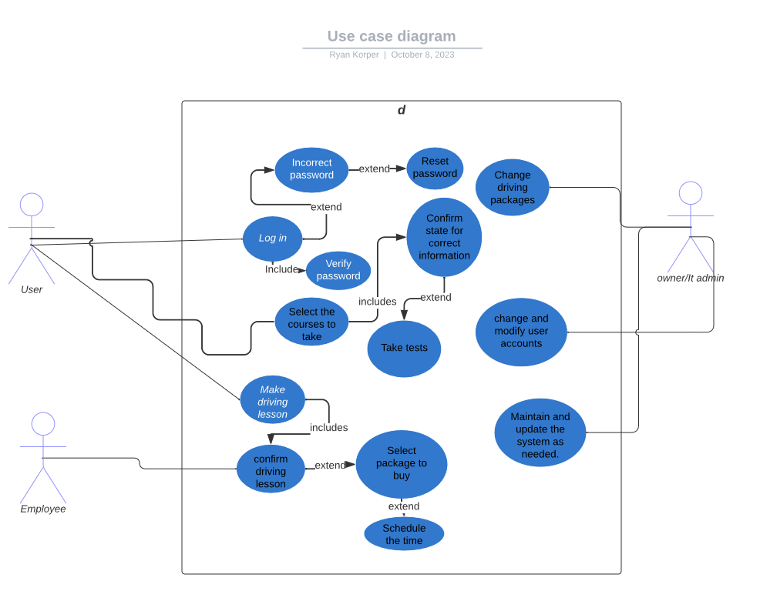

### UML Activity Diagrams

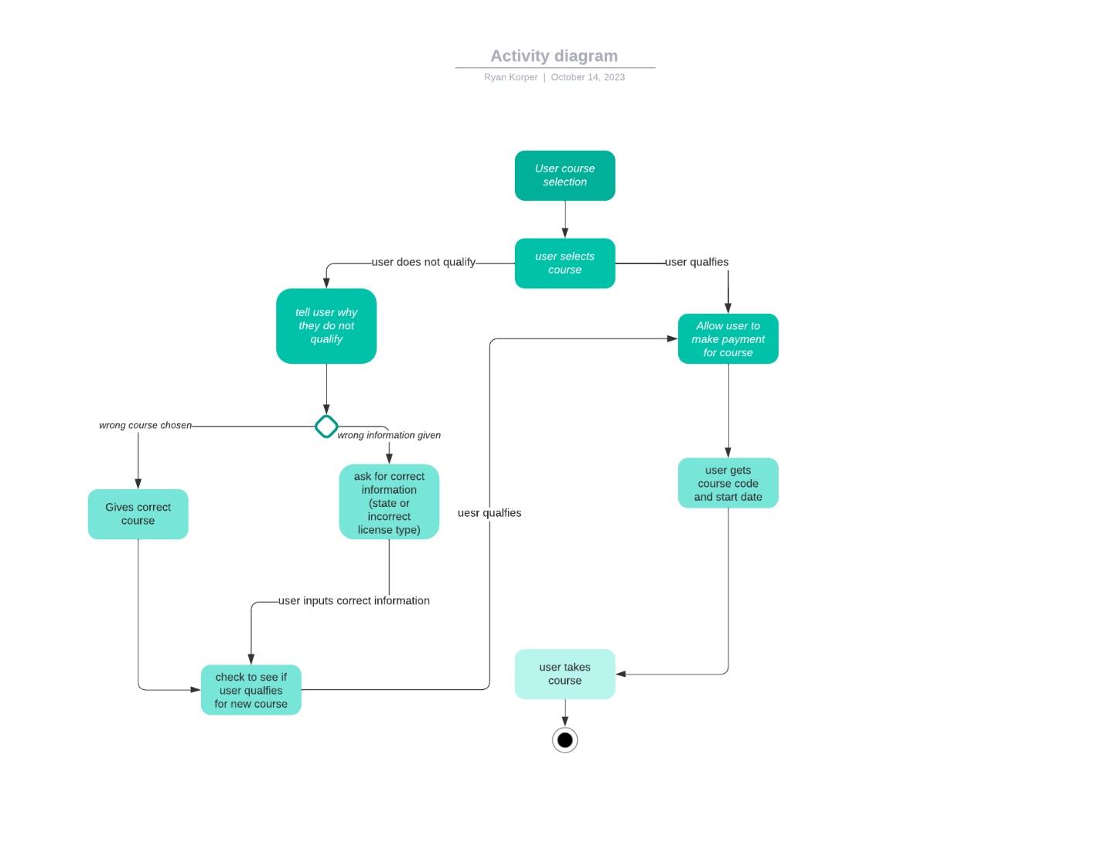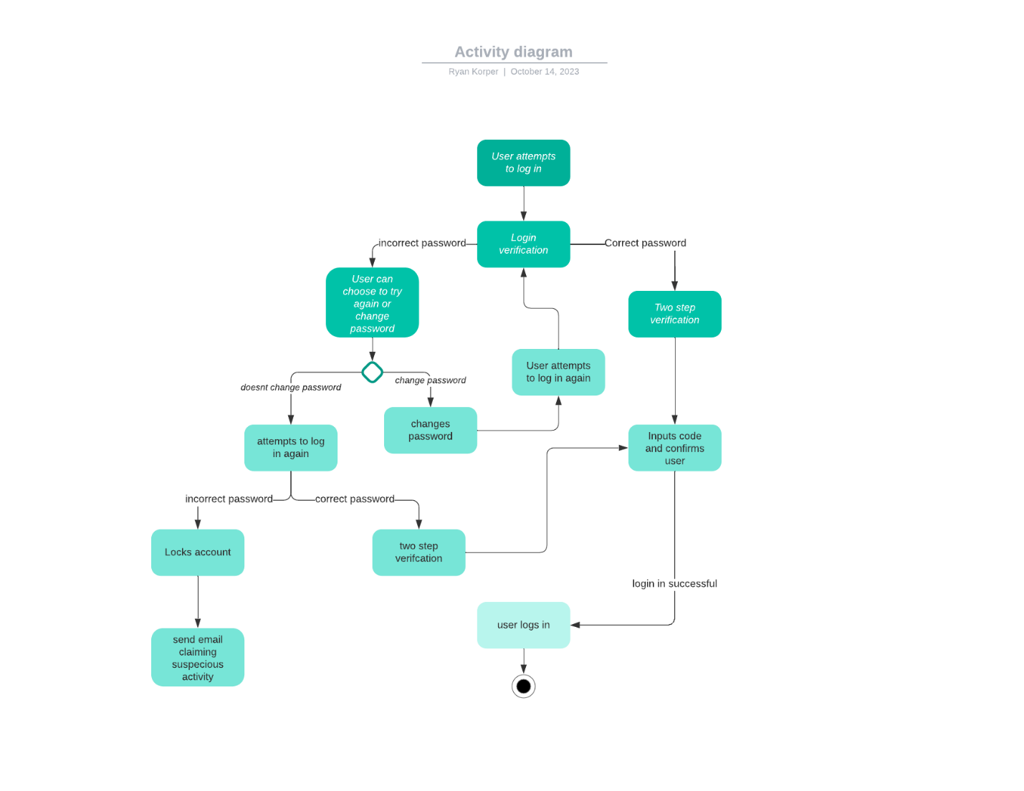

### UML Sequence Diagram

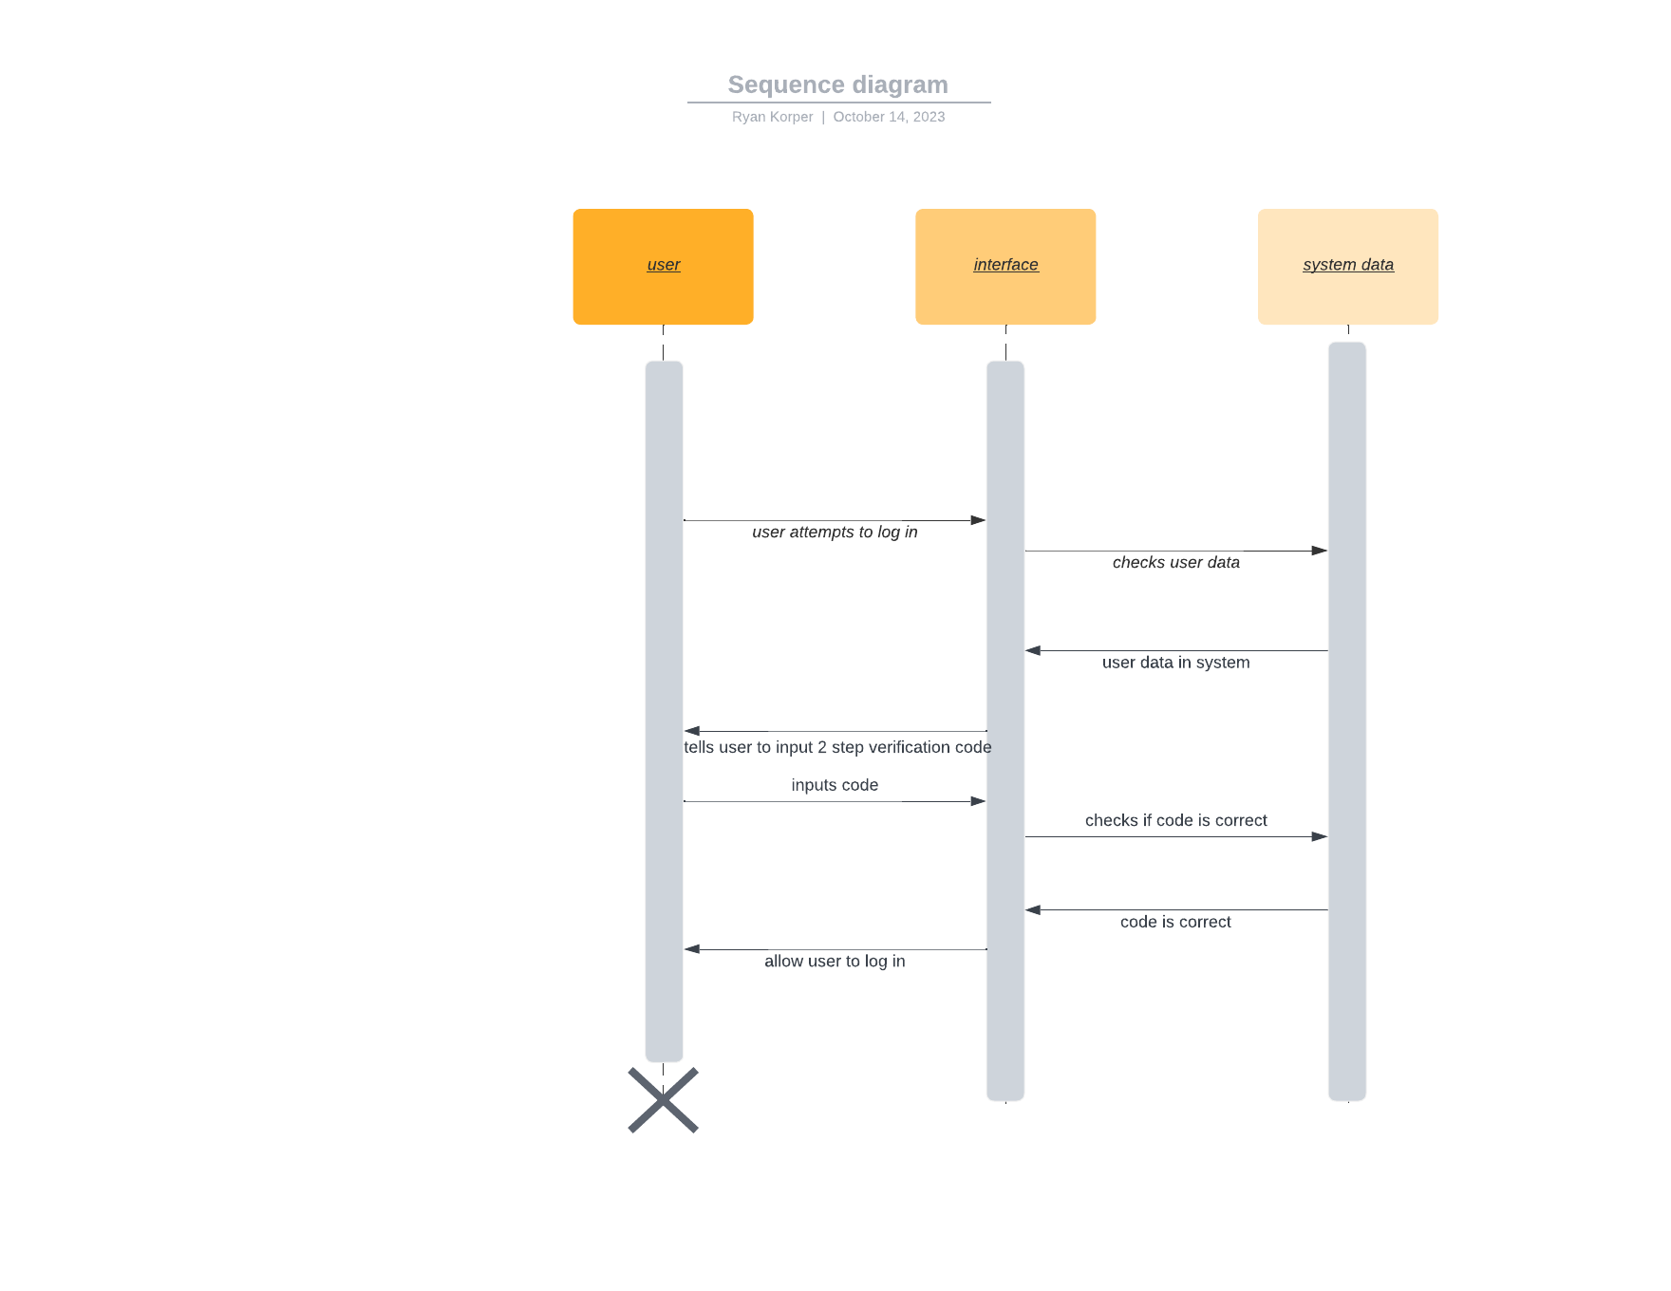

### UML Class Diagram

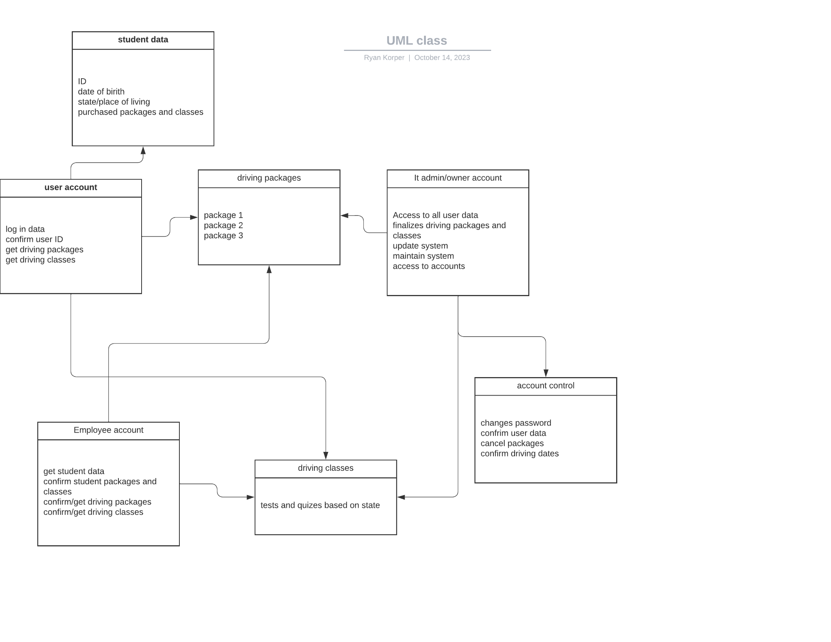

## Technical Requirements

*[Based on the diagrams you have created, describe the technical requirements of your system. These requirements should address the required hardware, software, tools, and infrastructure necessary for your system design.]*

Based on the diagram I have created, we do not have too many technical requirements. First of all, the hardware we would need will be basic windows machines, as they have they most tools available to us for use on creating our app. Being that this will be a web based program, the Software I recommend using is either Eclipse or Visual studio code as both of these are simple to use and our team would have experience with these already. The infrastructure needed will be 4 teams to accomplish this. The first team will be focused on the user data, the students, and making a overall log in page for data to be input, the second team will be focused on employee data, primarily on making their account able to confirm different packages and classes for students. Third team will focus on the IT admin and owner accounts. These accounts will be largely the same with the IT admin having more access to upload data to keep the app updated. Fourth team will focus on servers and making sure traffic will stay clear and not congested during large user activity. Each team will consist of 3-4 members and one leader. The leaders will MAKE SURE to keep in contact with each other on where their teams are and making sure that everything will go together.

Every day a scrum meeting will be held to make sure the teams are communicating with each other to help make sure the pieces are working together. At the end of each week when the app is partially useable we will, one member from each team will focus on bug solving so they can collect information on how the other teams programming is affecting their team or vice versa. We may be 4 smaller teams, but we need to work together to keep everything cohesive.